**EXPERIMENT 11**

**AIM: Write a program which will perform file operations in Node js using file system module.**

**CODE:**

***npm init -y*:** Initialize Node.js project by creating a package.json file

**fileOps.js:**

const fs = require('fs');

const fileName = 'firstgame.txt';            // Original file name

const newFileName = 'indiegame.txt'; // Renamed file name

*// 1. Create and write to a file (writeFile)*

fs.writeFile(fileName, 'Hello, this is my new game called "STAYIN AWAKE".', (err) => {

  if (err) throw err;

  console.log(`${fileName} created and content written!`);

*// 2. Append content to the file (appendFile)*

  fs.appendFile(fileName, '\nIt is a psychological horror game.', (err) => {

    if (err) throw err;

    console.log(`Content appended to ${fileName}!`);

*// 3. Read the file (readFile)*

    fs.readFile(fileName, 'utf8', (err, data) => {

      if (err) throw err;

      console.log(`${fileName} content:\n`, data);

*// 4. Rename the file (rename)*

      fs.rename(fileName, newFileName, (err) => {

        if (err) throw err;

        console.log(`${fileName} renamed to ${newFileName}!`);

*// 5. Delete the file (unlink)*

        fs.unlink(newFileName, (err) => {

          if (err) throw err;

          console.log(`${newFileName} deleted!`);

        });

      });

    });

  });

});

**1. Create and write to a file:**

* fs.writeFile() creates a file named firstgame.txt and writes the initial content.

**2. Append content to the file:**

* fs.appendFile() adds more content to the existing example.txt.

**3. Read the file:**

* fs.readFile() reads the content of the file and displays it.

**4. Rename the file:**

* fs.rename() renames firstgame.txt to indiegame.txt.

**5. Delete the file:**

* fs.unlink() deletes the renamed file.

**OUTPUT:**

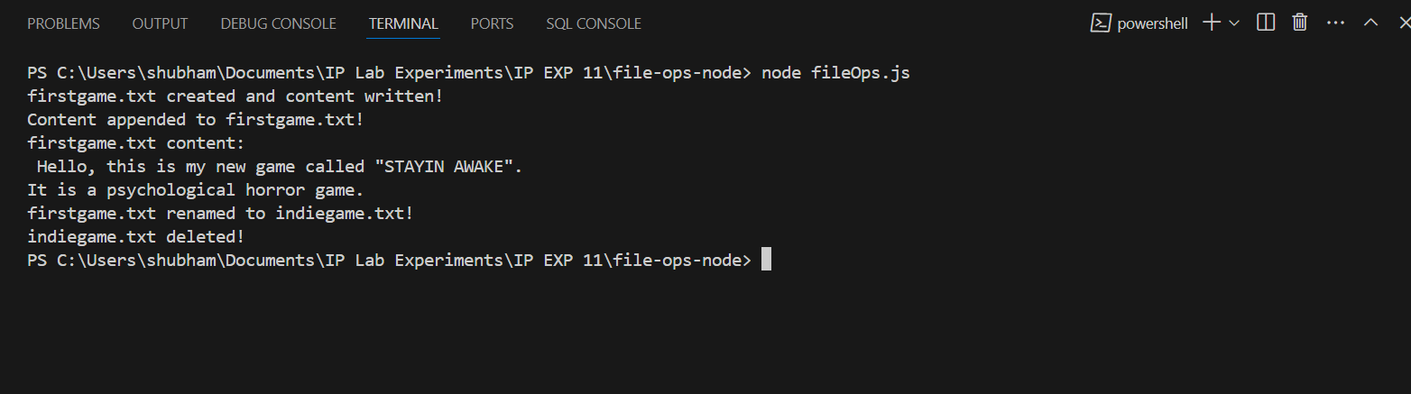

**CONCLUSION: Hence, we have successfully implemented a program which will perform file operations in Node js using file system module.**